Microcontroller Based Anesthesia Injector

FROM:

Engr Rana Muhammad Shakeel
Engnr.shakeel@gmail.com
https://www.facebook.com/EngnrShakeel
plz like my page:
https://www.facebook.com/Electrical4Electronics

For MORE PROJECTS:
http://electro-technolgy.blogspot.com

ABSTRACT

In the hospitals when any major operation is performed, the patient must be in anesthetize condition. If the operation lasts for a long time, say for suppose for 4 or 5 hours, complete dose of anesthesia cannot be administered in a single stroke. It may lead to the patient’s death. If lower amount of anesthesia is administered, the patient may wakeup at the middle of the operation.
To avoid this, the anesthetist administers few milliliters of anesthesia per hour to the patient. If the anesthetist fails to administer the anesthesia to the patient at the particular time interval, other allied problems may arise.
To overcome such hazardous problems the design of an automatic operation of an anesthesia machine based on a micro-controller is effective. In this system a keypad is provided along with the microcontroller and syringe infusion pump. The anesthetist can set the level of anesthesia in terms of milliliters per hour to administer anesthesia to the patient with the help of keypad.
After receiving the signal from the keypad, the microcontroller controls the signal to the desire level and fed into the stepper motor to drive the infusion pump in proper manner. The anesthesia is administered to the patient according to the stepper motor rotation (the syringe will move forward or backward direction).
This particular paper will be very much useful to physicians to see the current position of anesthesia of the patients. If the level of anesthesia is decreased to lower level (set value), the alarm will be initiated to alert the physician to refill the anesthesia in the Syringe Pump to continue the process.

INTRODUCTION

EMBEDDED SYSTEMS
An Embedded system is a combination of computer hardware, software and additional mechanical parts designed to perform a specific function. An example is the microwave oven. It is hardly realized that the oven actually consists of a processor and the software running inside. Another example is the TV remote control. Very few actually realize that there is a microcontroller inside that runs a set of programs especially for the TV. Automatic Anesthesia Injector system is also an application of embedded technologies in which a microcontroller is used to control the entire device.

MICROCONTROLLER
A Microcontroller is a general-purpose device that is meant to read data, perform limited calculations on that data and control its environment based on those calculations. The prime use of a microcontroller is to control the operation of a machine using a fixed program that is stored in ROM and that does not change over the lifetime of the system. A microcontroller is a highly integrated chip that includes all or most of the parts needed for a controller in a single chip. The microcontroller could be rightly called a one-chip solution.

MICRO CONTROLLER Vs MICRO PROCESSOR
If a system is developed with a microprocessor, the designer has to go for external memory such as RAM, ROM or EPROM and peripherals and hence the size of the PCB will be large to hold all the required peripherals. But, the micro controller has got all these peripheral facilities on a single chip and hence development of similar system with micro controller reduces PCB size and the overall cost of the design.The difference between a Microprocessor and Microcontroller is that a Microprocessor can only process with the data, but Microcontroller can control external device in addition to processing the data. If a device has to be switched “ON” or “OFF”, external ICs are needed to do this work. But with Microcontroller the device can be directly controlled without an IC. A Microcontroller often deals with bits, not bytes as in the real world application, for example switch contracts can be open or close, indicators should be lit or dark and motors can be either turned on or off and so forth.

AUTOMATIC ANESTHESIA INJECTOR (AAI)
Major operations are performed to remove or reconstruct the infected parts in the human body. These operations will lead to blood loss and pain. Therefore it is necessary to arrest the pain and the blood loss. Anesthesia plays an important role in the part of painkilling .AAI can be defined as “Automatic administration of anesthesia based on the bio-medical parameters of the patient, eliminating future side effects and the need for an anesthetist.”
Anesthesia is very essential in performing painless surgery and so an Automatic administration of Anesthesia is needed for a successful surgery.
PRESENT SYSTEM USED
At present anesthetist controlled manual operation is employed, which may cause many difficulties such as,
Ø Level of anesthesia may get varied and there is a chance of getting side effects in future.
Ø If suppose the anesthetist fails to administer the level of anesthesia during the predetermined period, the patient may be disturbed during the operation.
Ø Other systems developed to administer anesthesia operates by sensing the consciousness level of the patient and not by measuring his overall body conditions.

PROPOSED SYSTEM
Now days, embedded systems are used in many applications in medical field for controlling various biomedical parameters. In this design, a micro-controller is used for controlling the anesthesia machine automatically, depending upon the various biomedical parameters such as body temperature, heart rate, respiration rate etc.
Major operations are performed to remove or reconstruct the infected parts in the human body. These operations lead to blood loss and pain. Therefore it is necessary to arrest the pain and the blood loss. Anesthesia plays important role in the part of painkilling. Hence, anesthesia is very essential in performing painless surgery. Advantages of using the proposed system are,
Ø The need for an anesthetist is eliminated.
Ø Level of anesthesia is not varied, so the future side effects are eliminated.
Ø IR detector is also included in the system for monitoring the total anesthesia level for the entire period of the surgery time.

BLOCK DIAGRAM

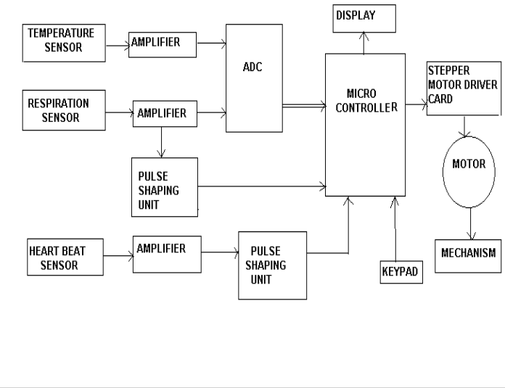

WORKING OF THE SYSTEM
By using the keypad provided along with the Microcontroller, the anesthetist can set the level of anesthesia to be administered to the patient in terms of milliliters per hour (1ml to 1000ml).After receiving the anesthesia level from the keypad, the Microcontroller sets the system to administer anesthesia to the prescribed level. It then analyses various bio-medical parameters obtained from the sensors to determine the direction of rotation of the stepper motor. The rotation of the stepper motor causes the Infusion Pump to move in forward or in a backward direction and the anesthesia provided in the syringe is injected into the body of the patient. If the level of anesthesia is decreased to lower level than the set value, the alarm gets activated to alert the anesthetist to refill the anesthesia in the syringe pump to continue the process. In this design, the total timing and opposite flow of blood will also be detected by using Micro Controller.

COMPONENTS REQUIRED FOR THE SYSTEM
Ø Temperature Sensor – to measure body temperature
Ø Respiration Sensor – to measure respiration
Ø Heart Beat Sensor – to measure heartbeat
Ø Micro-Controller – to Control the overall operation
Ø Stepper Motor – to control the movement of the Syringe Infusion Pump
Ø A/D Converter – to convert the analog information in to a digital format.

MEASUREMENT OF BIO-MEDICAL PARAMETERS
The measurement of bio-medical parameters is a vital process. These parameters determine the overall condition of the patient. It plays a very significant process in the level of anesthesia that has to be administered to the patient. Only based on these parameters the movement of the stepper motor is determined. Transducers and Thermistors are the key links in all sensors designed to describe and analyze the bio-medical parameters. The transducers used here are just those that find applications in patient monitoring systems and experimental work on four parameters namely blood pressure, temperature, pulse and respiratory activity. Both transducers and thermistors are made in a wide variety of forms suitable for use in medical applications. They are available as
Ø wafers for applying on the skin surfaces
Ø tiny beads for inserting into the tissues
.
TEMPERATURE SENSOR
The most accurate method to measure temperature is to use Thermistors and Resistance Thermometers. Thermistor or thermal resistor is a two-terminal semiconductor device whose resistance is temperature sensitive. The value of such resistors decreases with increase in temperature. The thermistors have very high temperature coefficient of resistance of the order of 3% to 5% per ºC, making it an ideal temperature transducer. The temperature co-efficient of resistance is normally negative. The output of the temperature sensor is given to the amplifier stages. Resistance thermometers can also be used to measure the body temperature. Important characteristics of resistance thermometers are high temperature co-efficient to resistance, stable properties so that the resistance characteristics does not drift with repeated heating or cooling or mechanical strain and high resistivity to permit the construction of small sensors.

Circuit to measure Temperature

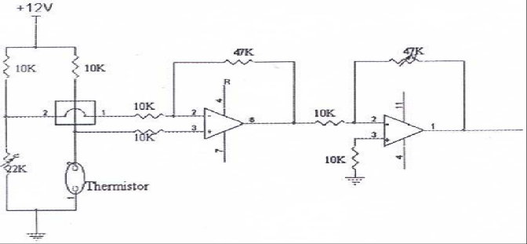

RESPIRATION SENSOR
The primary functions of the respiratory system are to supply oxygen to the tissues and remove carbon dioxide from the tissues. The action of breathing is controlled by muscular action causing the volume of the lung to increase and decrease to affect a precise and sensitive control of the tension of carbon dioxide in the arterial blood. Under normal circumstances, this is rhythmic action.

Circuit to measure Respiration
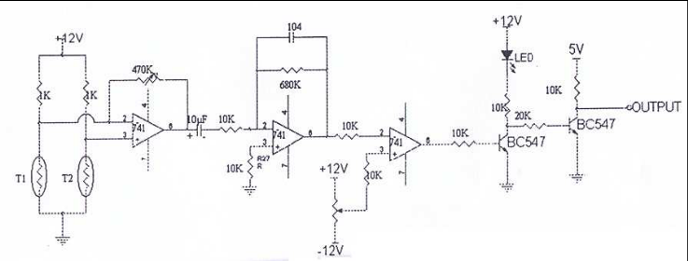

Respiratory activity can be detected by measuring changes in the impedance across the thorax. Several types of transducers have been developed for the measurement of respiration rate. A Strain Gauge type Chest Transducer is a suitable transducer to measure the respiratory activity. The respiratory movement results in the changes of the strain gauge element of the transducer hence the respiration rate can be measured.

HEART BEAT SENSOR
Heart rate is our body's way of telling how hard it is going. It is very vital that heart beat has to be in normal while administering anesthesia to the patient. Normal heart beat is 72 beats per minute. A sensor is designed for monitoring the changes in the heart beat of the human body. There are 2 ways of monitoring heart rate information from the body. They are
Ø Electrocardiogram (ECG)
Ø PULSE
1) The E.C.G or Electrocardiogram, gives the electrically picked up signals from the limbs due to the nervous activity of the heart. The electrodes are pasted on to the 2 hands and the left leg, the right leg electrode serving as the common or ground reference. The signals are picked up and amplified by high gain differential amplifiers and then the electrocardiogram signal is obtained.
2) The pulse signal refers to the flow of blood that passes from the heart to the limbs and the peripheral organs once per beat. Usually, the physician looks for the pulse on the wrist of the patient. The artery is near the surface of the skin and hence easily palpable. This pulse occurs once per heart beat. These pulse signals can be picked up by keeping a piezo-electric pick up on the artery site (in the wrist).

DESIGN OF A MICROCONTROLLER
The design approach of the microcontroller mirrors that of the microprocessor. The microprocessor design accomplishes a very flexible and extensive repertoire of multi-byte instructions. These instructions work in hardware configurations that enables large amount of memory and IO to be connected to address and data bus pins on the integrated circuit package. The microcontroller design uses a much more limited set of single and double byte instructions that are used to move code and data from internal memory to the ALU. The pins are programmable that is capable of having several different functions depending on the wishes of the programmer. It is concerned with getting data from and to its own pins

.89C51 MICRO CONTROLLER
The Microcontroller that is used in this system is 89C51 manufactured by Atmel, MC, USA.
This is an advanced version of 8031.
SERIES : 89C51 Family
TECHNOLOGY : CMOS
The major features of 8-bit micro controller ATMEL 89C51:
Ø 8 Bit CPU optimized for control applications
Ø Extensive Boolean processing (Single-bit Logic) Capabilities
Ø On-chip Flash Program Memory
Ø On-chip Data RAM
Ø Bi-directional and Individually Addressable I/O Lines
Ø Multiple 16-Bit Timer/Counters
Ø Full Duplex UART
Ø Multiple Source/Vector/Priority Interrupt Structure
Ø On-Chip Oscillator and Clock circuitry
Ø On-Chip EPROM
Ø SPI Serial Bus Interface
Ø Watch Dog Timer
Flash ROM
The 4-kb ROM in the microprocessor can be erased and reprogrammed. If the available memory is not enough for the program an external ROM can be interfaced with this IC. AT89C51 has 16 address lines, so a maximum of (2^16) i.e. 64 bytes of ROM can be interfaced. Both internal and external ROM can be used simultaneously.
RAM
The Microcontroller provides internal 256 bytes of RAM. Theses 256 bytes of internal RAM can be used along with the external RAM. Externally a 64-kb of RAM can be connected with the microcontroller. In internal RAM first 128 bytes of RAM is available for the user and the remaining 128 bytes are used as special function registers (SFR). These SFRs are used as control registers for timer, serial port etc.
Input/Output port Four I/O ports are available in AT89C51. They are Port 0, Port 1, Port2 and Port 3. These ports are eight bit ports and can be controlled individually. In addition to this the ports also has pull-up registers to maximize its use.
Interrupts
The AT 89C51 provides 5 Interrupt sources:
Ø 2 external interrupts – INT0 and INT1
Ø 2 timer interrupts – TF0 and TF1
Ø a serial port interrupts.

Memory
The memory is logically separated into Program memory and Data memory. This logical separation allows the data memory to be addressed by 8-bit address. Program memory can only read the information. There can be up to 64 bytes of directly addressable program memory.

ADC 0808/0809
The ADC 0808/0809 is an 8-bit digital to analog converter with 8-channel inbuilt Multiplexer. It is the monolithic CMOS device manufactured by the National semiconductors. It uses the principle of Successive Approximation technique for the conversion process. The 8-channel Multiplexer can directly access any of the 8-single-ended analog signals. Easy interfacing to the microcontrollers is provided by the latched and decoded multiplexers address inputs and latched TTL TIR-STATE outputs.
The salient features are:
Ø High Speed and Accuracy
Ø Minimal temperature Dependence
Ø Excellent temperature dependence
Ø Excellent long term accuracy and repeatability
Ø Consumes minimal power. (15 mW)
These features make this device ideally suited to applications from process and machine control to consumer and automotive applications.

STEPPER MOTOR
A stepper motor transforms electrical pulses into equal increments of rotary shaft motion called steps. A one-to-one correspondence exists between the electrical pulses and the motor steps. They work in conjunction with electronic switching devices. The function of switching device is to switch the control windings of the stepper motor with a frequency and sequence corresponding to the issued command. It has a wound stator and a non exited rotor. Stepper motors are classified as 2-phase, 3-phase or 4-phase depending on the number of windings on the stator.

STEPPER MOTOR DRIVER CIRCUIT
In Automatic Anesthesia Injector, a 4-phase stepper motor is used. Consider the four phases as S1, S2, S3 and S4. The switch sequence can be used to rotate the motor half steps of 0.9º clockwise or counter clockwise.
To take first step clockwise from S2 and S1 being on, the pattern of 1’s and 0’s is simply rotated one bit position around to the right. The 1 from S1 is rotated around into bit 4. To take the next step the switch pattern is rotated one more bit position. To step anti-clockwise the pattern is rotated to the left by one bit position.

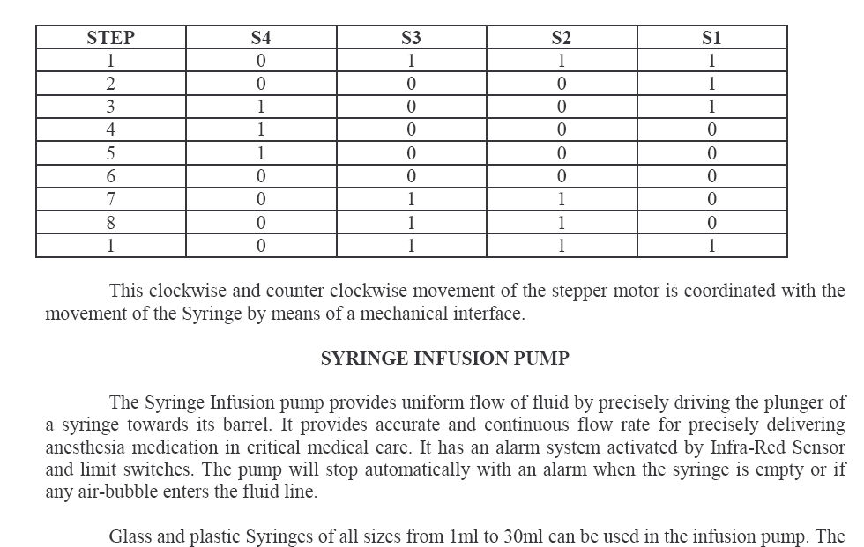
This clockwise and counter clockwise movement of the stepper motor is coordinated with the movement of the Syringe by means of a mechanical interface.

SYRINGE INFUSION PUMP
The Syringe Infusion pump provides uniform flow of fluid by precisely driving the plunger of a syringe towards its barrel. It provides accurate and continuous flow rate for precisely delivering anesthesia medication in critical medical care. It has an alarm system activated by Infra-Red Sensor and limit switches. The pump will stop automatically with an alarm when the syringe is empty or if any air-bubble enters the fluid line. Glass and plastic Syringes of all sizes from 1ml to 30ml can be used in the infusion pump. The flow rates can be adjusted from 1ml to 99ml/hr. Since it accepts other syringe size also, much lower flow rate can be obtained by using smaller syringes.

SOFTWARE DETAILS
A program is required which when burnt into the EPROM will operate with the AT 89C51 to do the function of monitoring the bio-medical parameters. The program answers the following requirements:

Ø To read the input from the keypad provided with the microcontroller.
Ø To activate the internal timer and enable it to interrupt the AT 89C51 whenever the timer overflows.
Ø To read the parameters such as heart rate, respiration, body temperature once in every specified interval.
Ø To check for the correctness of the parameter values and activate the alarm set with the system when the level of Anesthesia goes down.
Ø To calculate the stepper motor movement (increase the speed or decrease the speed) with the parameters provided by the Sensors.
Ø Continue the above until switched OFF or RESET.

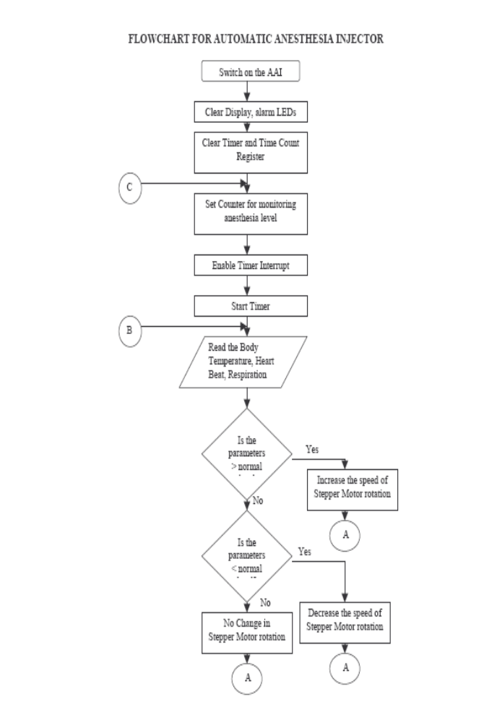
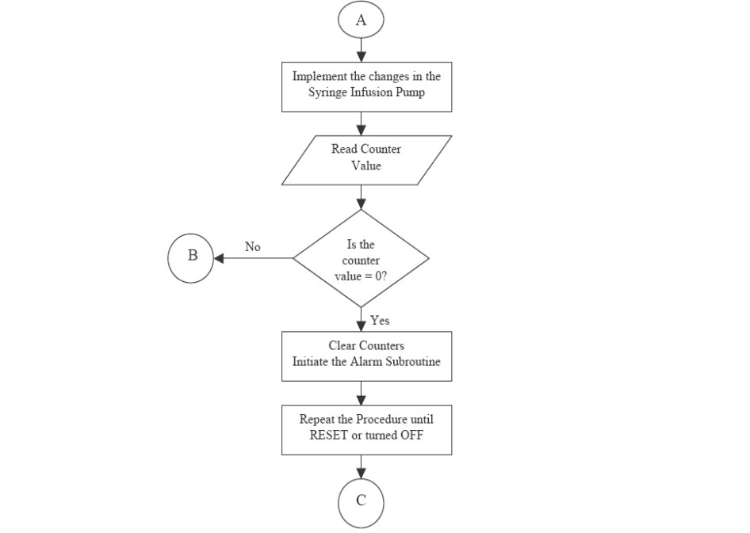
To Summarize:
By using various electrical circuits the bio-medical parameters can be found. The output of the circuits is amplified by means of an amplifier and fed into an A/D converter. The digitized signal is then fed into the input port of the Microcontroller. The Microcontroller displays the parameters in digital value in the display device. If the level of the temperature or respiration is increased or decreased the level of anesthesia was controlled automatically with the help of micro-controller and the stepper motor actions.

EXPERIMENTAL RESULTS
The performance of the microcontroller was checked virtually by interfacing it with the computer. The program was written in the micro controller for analyzing the parameters. Then the microcontroller was interfaced with the PC using the Microsoft Communication Port interface in Visual Basic 6.0.
A Stepper motor designed in VB was made to run and the motor speed on various conditions was noted. When the respiration rate and the temperature were constant, the motor speed was found to be constant. When this parameter was varied (by manually coding the change in the microcontroller program), the stepper motor speed was also found to vary with the aid of the microcontroller.

Interface developed in Visual Basic

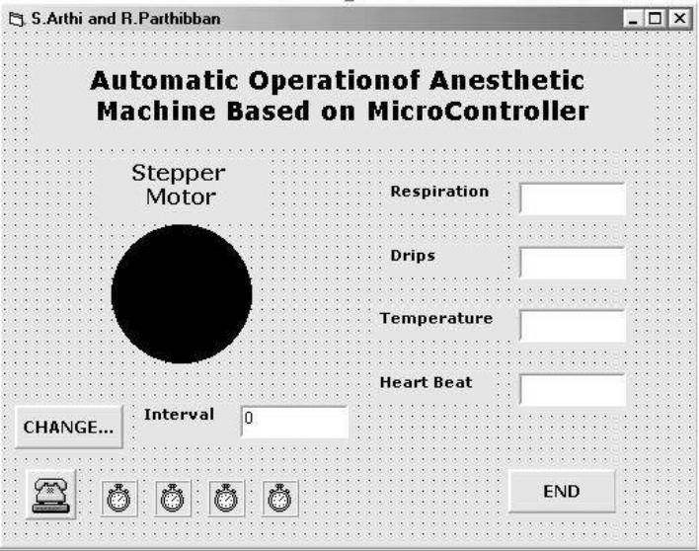

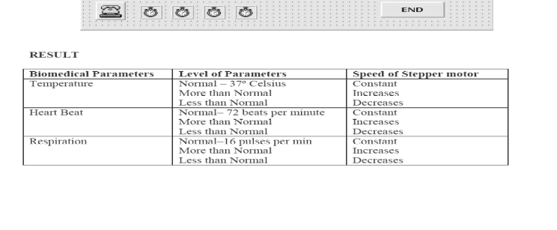
FUTURE ENHANCEMENTS
Ø Multiple parameters like Blood pressure, retinal size, age and weight can be included as controlling parameters in the future.
Ø Specialized embedded anesthesia machine can be developed, thereby reducing size, cost and increasing efficiency.

CONCLUSION
Modern technologies have developed that promotes comfortable and better life which is disease free. PREVENTION IS BETTER THAN CURE and protection is intelligent than prevention and our presentation on MICROCONTROLLER BASED ANESTHESIA MACHINE is one of the efficient protecting systems.

REFERENCES
1. Microcontroller and their applications – Kenneth J.Ayalaa – Penram International.
2. Bio medical Instrumentation and Application – William John Webster.

